Data Modification Problem4
- Modification Statement
UPDATE Location
SET LocName = 'Gate'
WHERE LocNo= 'L107';
- Before (9 rows)
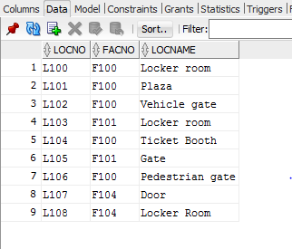
- Updated
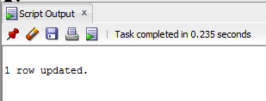
- After(Row updated)
